1xBet’s Curaçao License in Place and Fully Operational

In connection with a recent media report which appeared on a small activist website featuring inaccurate information about 1xBet, we believe it is appropriate to provide the factually accurate position.

1xBet is a leading global bookmaker brand which has licenses in several international markets, including Curacao, which is home to many global gaming and betting companies. 1xBet has encountered no issues concerning its Curacao license, which remain in place and with which it is fully compliant, and everything is business as usual. 1xBet and its franchises have always fulfilled their obligations to customers and partners in full.

Any reporting to the contrary is without foundation and entirely false and 1xBet urges those interested members of the media to carefully check the facts and avoid relying on unsubstantiated rumour and baseless speculation before publishing to avoid printing factually inaccurate content.
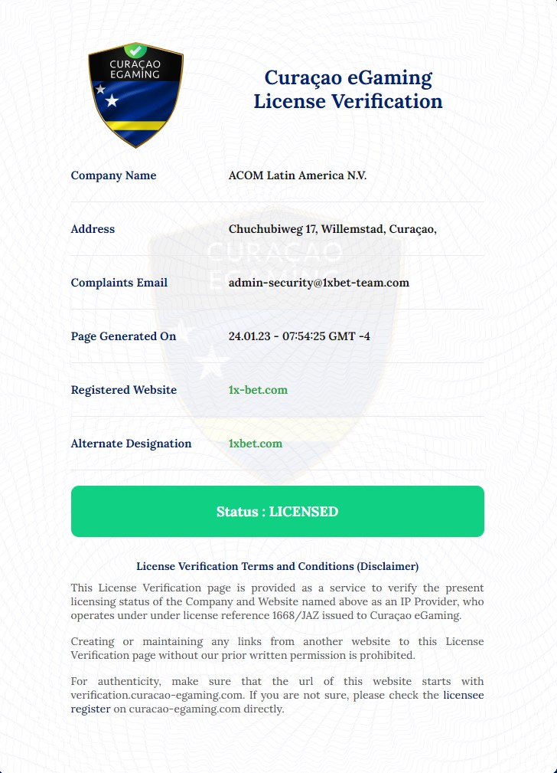

On 20 January 2023, an article appeared on Josimar, a small sports activist website, alleging that 1xBet was ‘declared bankrupt’. Josimar has occasionally covered 1xBet in the past and its coverage has been filled with factual inaccuracies and this recent article is no exception. The article can only be described as a mixture of fantasy and a littering of random statements with no basis in reality or fact.

We would like to focus on what we consider key allegations made by Josimar below, with explanations included:

It states 1xBet ‘was declared bankrupt this week’. This is, of course, complete nonsense. 1xBet is one of the fastest growing and biggest gambling brands in the world.

It states that 1xCorp, a Curacao company, is the ‘owner’ of 1xBet. This is false. 1xBet is headquartered in Cyprus with thousands of employees.

It states that 1xBet is a ‘Russian bookmaker’. This is false. 1xBet is a global gambling brand, headquartered in Cyprus with operations across Latin America, Europe, Africa and Asia, working via a franchise model. Its products and services are blocked in Russia and Belarus.

It states the bankruptcy of 1xCorp relates to an action brought by the Foundation for Representation of Victims of Online Gaming (SBGOK), which supposedly represents customers claiming to be owned ‘roughly 830,000 euros’ in winnings. It states a similar case exists in Russia, including a suggestion that ‘1xBet has lost its license to operate in Russia.’ I would like to take these allegations in turn, as I believe they require context:

The 1xBet brand, via a global franchise model, has millions of customers, placing tens of millions of bets on sport around the world. 1xBet pays out all legitimate winnings in full and without delay. There are a very small number of occasions where either 1xBet or its franchise businesses identify suspicious bets and/or irregular betting patterns either through manual or automated monitoring systems. This is common practice within the gambling industry. In the event we believe winnings are not legitimate and terms and conditions have been broken, we reserve the right to withhold payment of winnings pending further investigation and will likely make requests for further information from the relevant account holders. In the event our investigation concludes that there has been a breach of our terms and conditions, winnings are withheld, as per the terms of our contract. These contested winnings are what is being pursued in Curacao.

1xCorp does not own 1xBet. It is a Curacao company which had, at one point, had various gaming platforms and businesses.

As for the Russian market, 1xBet cannot have lost its license there, because it did not have it in the first place. The action relates to another bookmaking business in Russia, which is neither owned or controlled by 1xBet.

The article states that 1xBet had ‘secured licenses’ to operate in Ukraine and the license had ‘been revoked’. This is complete nonsense. 1xBet had made a US$1m donation to the Red Cross relief effort in the country, one of the biggest by anyone in the industry. As for the suggestion it lose its license in Ukraine, this is, once again, untrue. Several Ukrainian companies expressed an interest in using a 1xBet license on a franchise basis but 1xBet itself never had any licenses in the country.

